Install Git hub
- Navigate to the git hub webpage: https://desktop.github.com/download/
- Choose the installation method relevant to your operating system
- Download the application
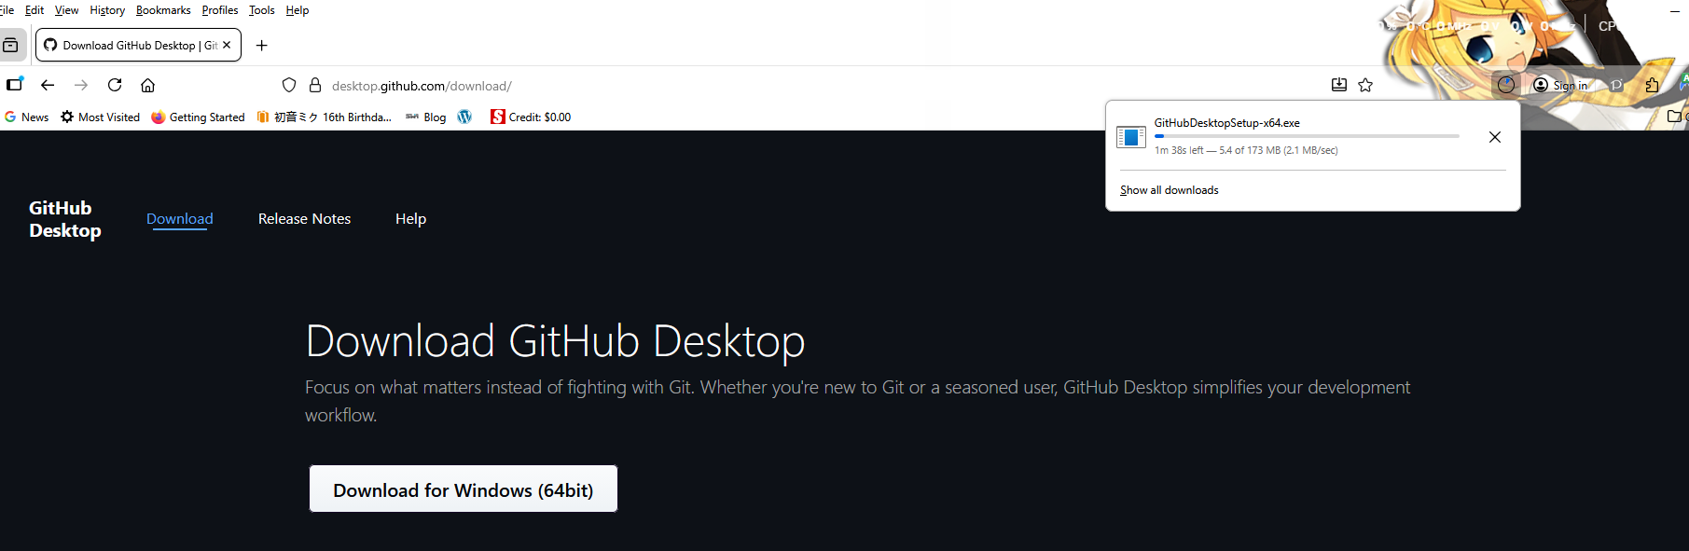
- Navigate to where you have installed the program and follow the installation instructions

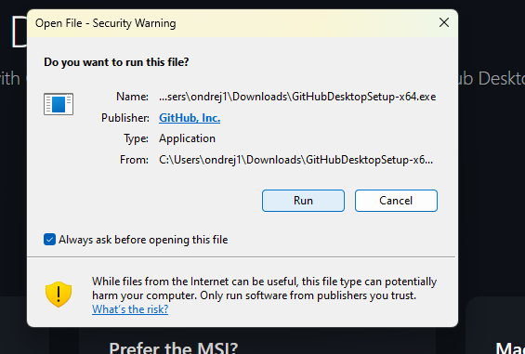

- Launch the program.
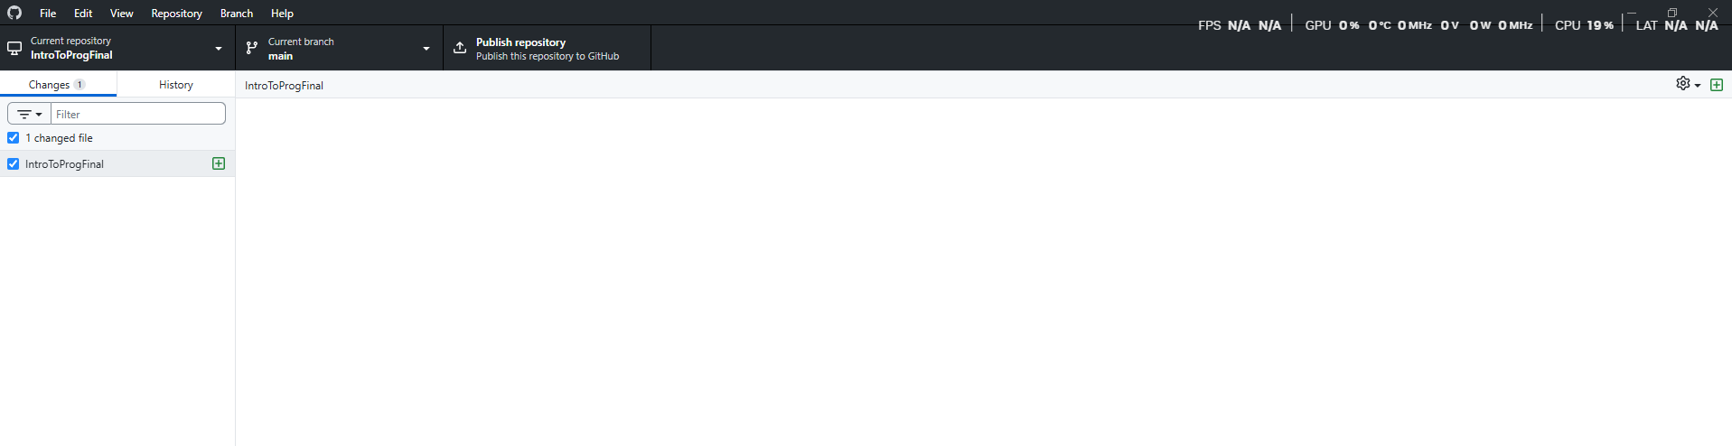
- Sign up for a GitHub account at this website and follow the prompts
https://github.com/
or use and existing google or outlook email account or a google r apply account

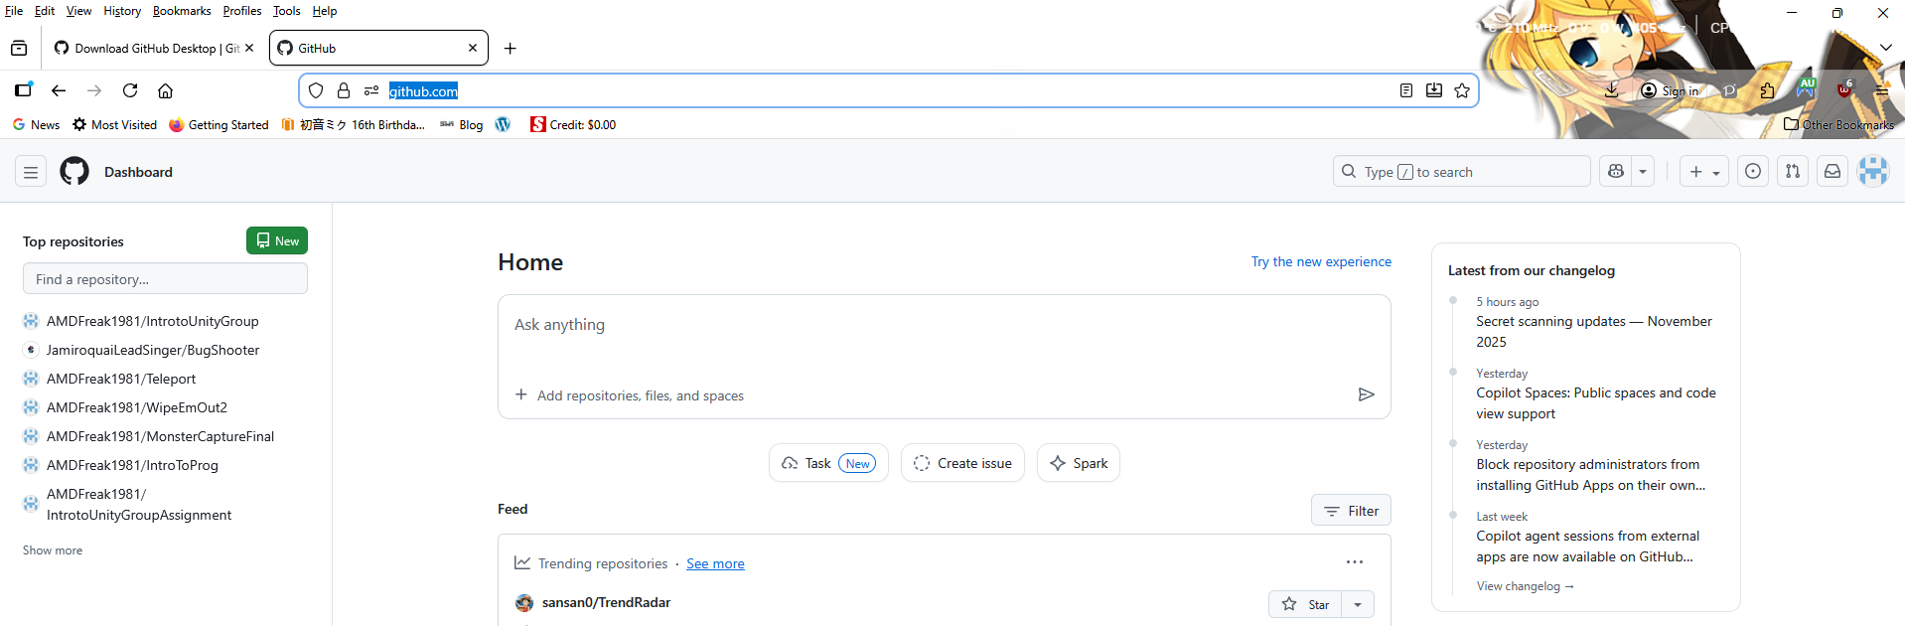
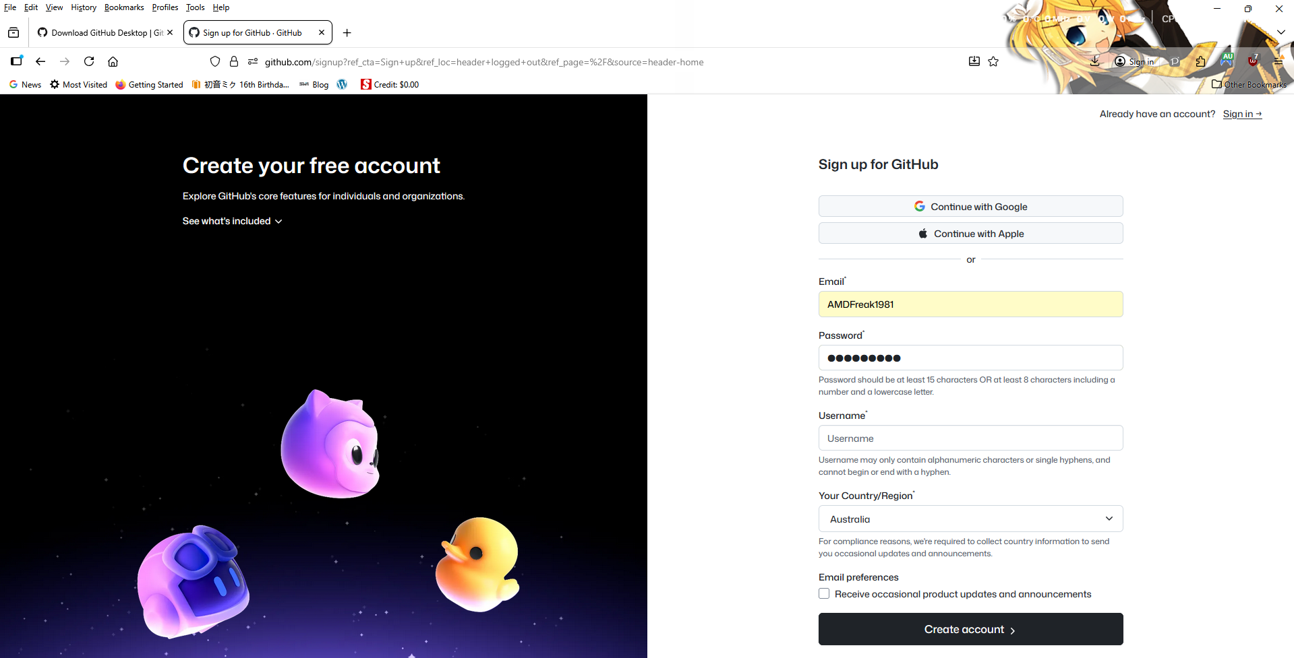

- Choose a username and a region. Then create a password and you're ready to go
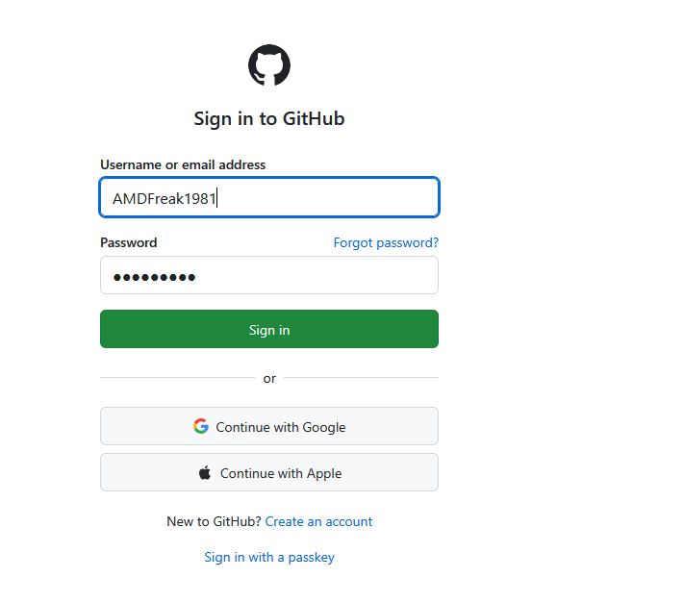

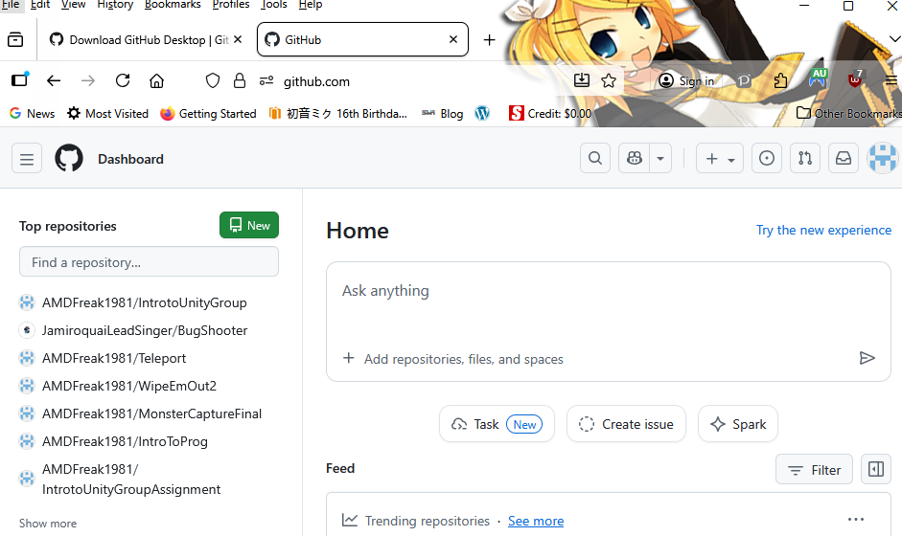
8.Create a new repository
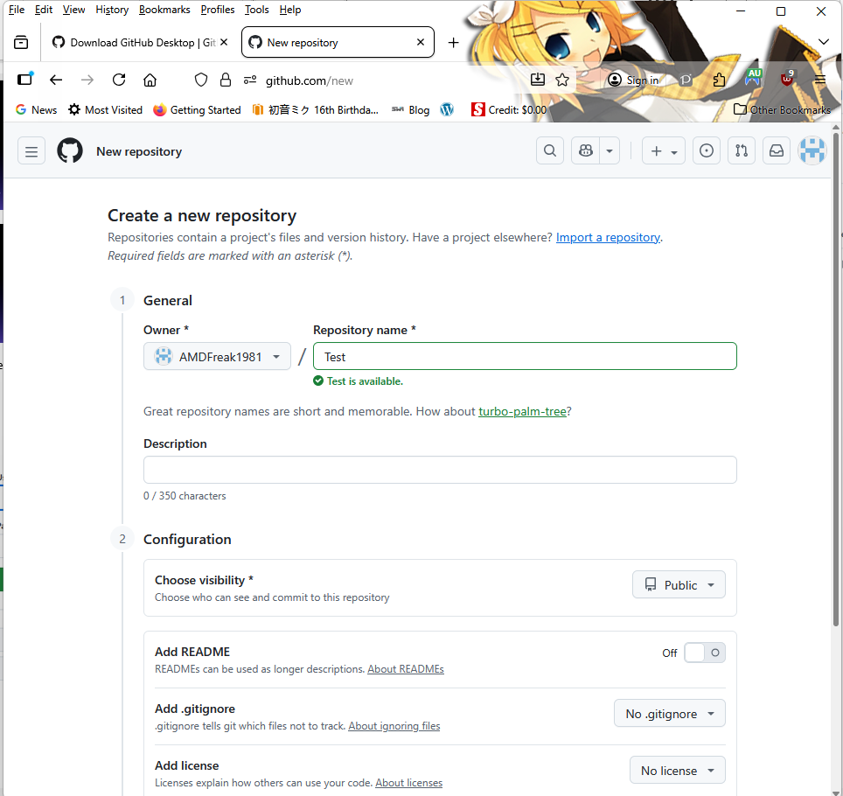
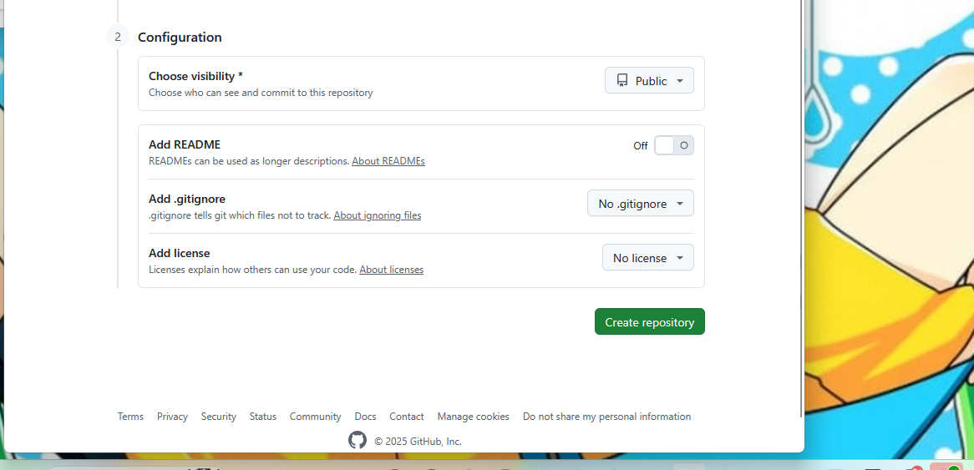
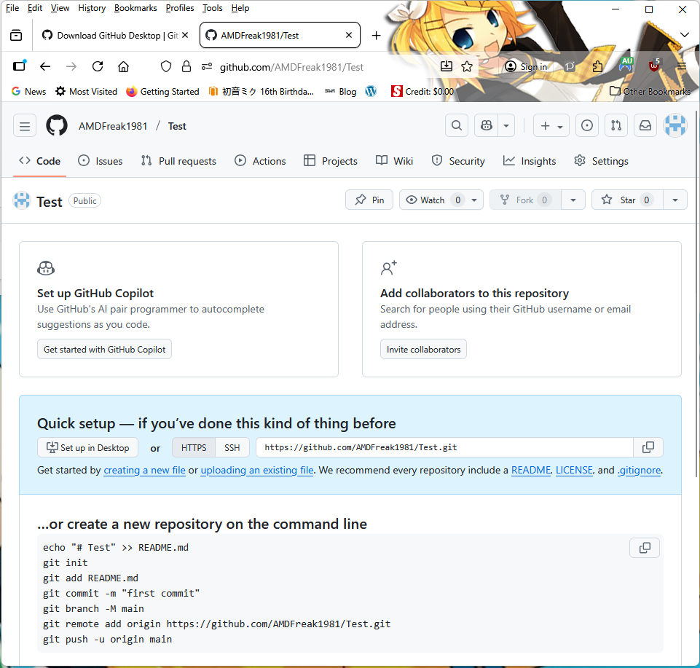
9.Now you’re ready to go.
67
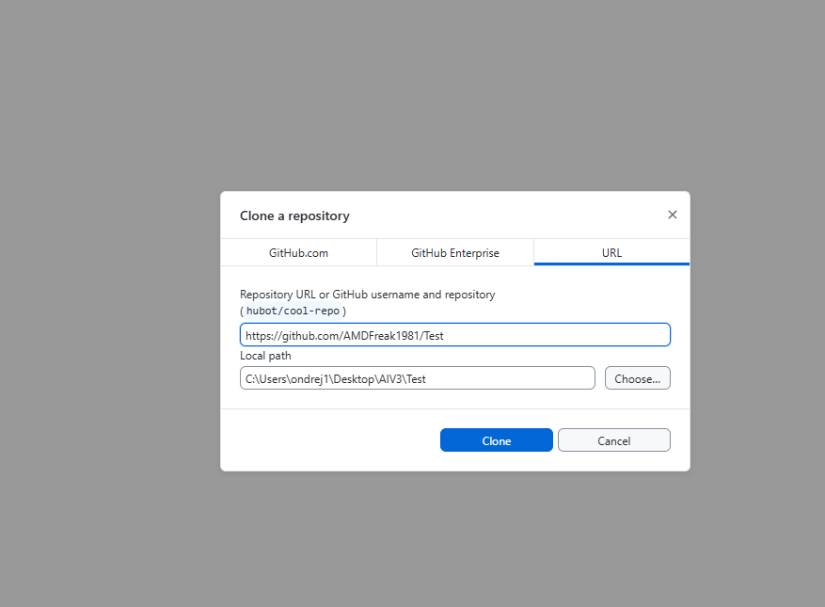
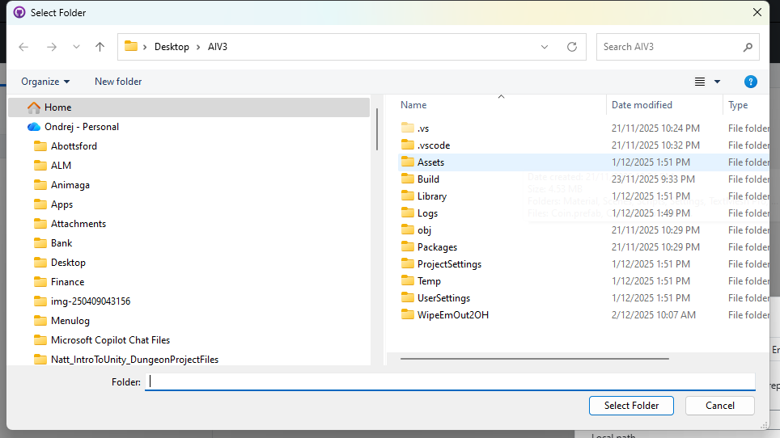
10.For any further help, please look here:
https://github.com/frequently-asked-questions
https://docs.github.com/en/get-started

